E-Commerce of Vietnam, the bright future is not too far but there are still barriers and problems to solve. According to a survey of BMI Research Group 2015 on Investors Bank On Asian e-Commerce Prospects, Vietnam has the smallest Asian e-Commerce market. At 0.1% of the total retail sales, Vietnam E-Commerce market was valued less than USD0.1bn in 2014 even though PWC Newsbrief Strategy Function of 2013 predicted that the market to reach USD2.8bn by 2015.

One of the biggest barriers for firms or e-commerce startups to get off the ground in Vietnam and other developing countries in Southeast Asia is the payment method, beside the weakness of infrastructure and logistic. However, if there is a problem, there is an opportunity, and it is fair for everyone to have chances to become market leaders in the long-run.

**Online Payment, too many but where is the problem solver?**

Although the country has one of the highest online shopping penetration rates in Asia, the lack of reliable integrated payment platform, weak infrastructure and poor logistics are still holding the market from getting off the ground. Online payment platform is the biggest problem with Vietnam E-Commerce market currently because a lot of factors. Since the last 5 years, there are some online payment companies established in Vietnam and from foreign countries such as 1Pay, NganLuong, Payoo/PayBill, BaoKim, or even PayPal but it seems like they have not touched the right pain. Vietnamese consumers still prefer retail or online shopping through social media like Facebook, Instagram, Zalo and then face to face payment transaction. The only way payment companies can be successful is to understand the consumers and find the right problems to solve. The problems are from consumer’s behavior of hands on inspection, the low credit/debit card penetration is still there and the most important thing, the trust.

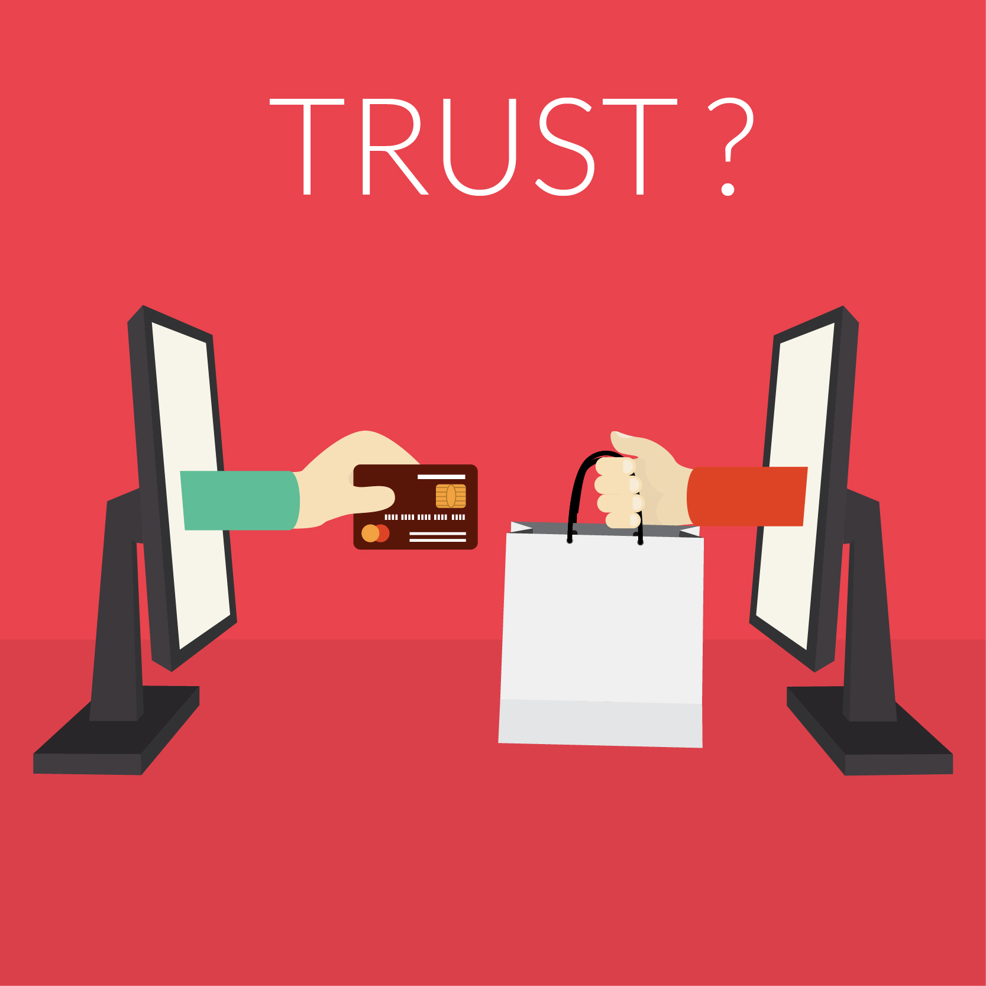

**The trust needs to be created, who has done it?**

The biggest factor which is holding the E-Commerce of Vietnam and other Southeast Asia developing countries is the trust of the seller and buyer when trading or shopping online. Southeast Asian consumers lose trust on the Internet in general and online shopping in specific is because the security, fraud and privacy issue. Also, product’s quality is a question mark when consumer about to place an order.

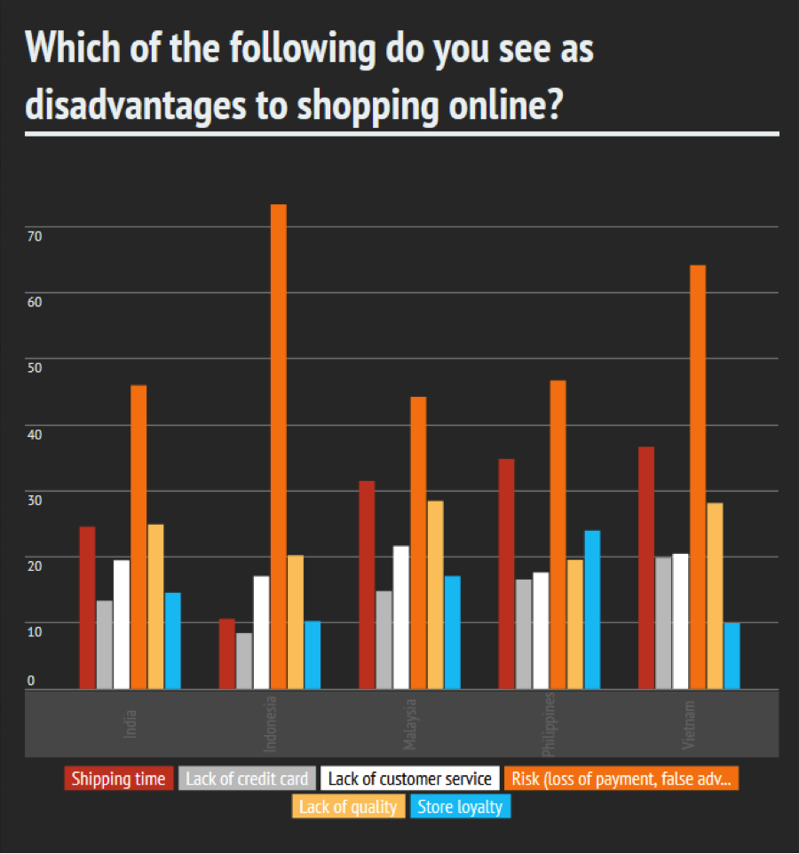How can we do thing online unless we have trust? Without the trust, it is impossible to do business. The trusted system, is the system where people can trust each other and place an order from a strange seller without hesitate. The question is still there, does anyone has made the trusted payment solution for Vietnam market in specific or Southeast Asia in general? The are some solutions which B2C E-Retails such as Lazada, Zalora has done to solve the problem is Cash On Delivery. However, Cash-On-Delivery (COD) still has not solved the "trust "problem for the long-tem grow of E-Commerce because there are still some limitations like logistical services, time consuming of delivery, labor and other fees.

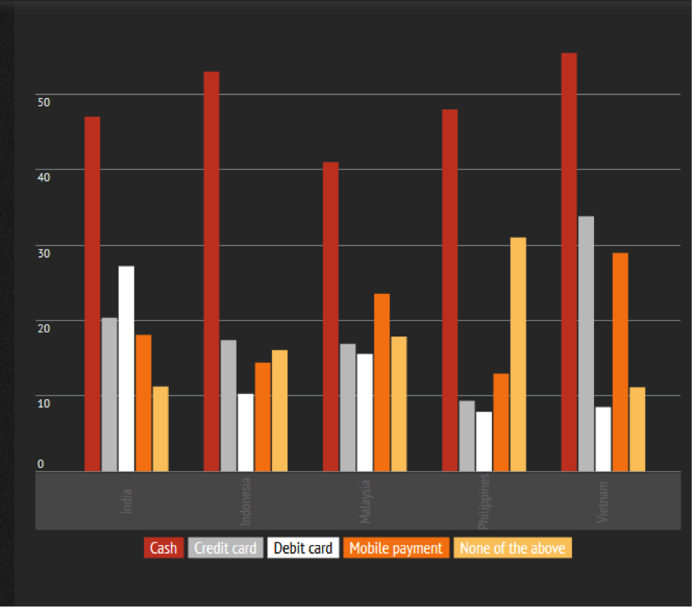

**There are E-Markets of information without payment option.**

Again, just similar to the payment problem. Vietnam has a lot of online marketplaces such as 5giay.vn, 123mua, nhattao…which are just the classified advertising or posting pages for people to post information. Consumers can’t do anything from those website except taking the information down and contact the seller through phone number or email. The old style Marketplace, the forum-based marketplace is the common place where Vietnamese urban people shop online similar to Craigslist of the U.S. Obviously, there are a lot of risks, security and scam issues.

According to the survey by Vietnam E-commerce and Information Technology Agency (VECITA) in 2014, the online purchases per person was estimated at about 145 USD. Cash was the majority payment method for online transactions (64% of respondents) due to the lack of trusted payment platform, even though having decreased 10% when compared a earlier to 2014. Bank transfers also made decrease from 41% in 2013 to 14% in 2014. However, the number of people using electronic wallets grew 8% in 2013 to 37% in 2014.

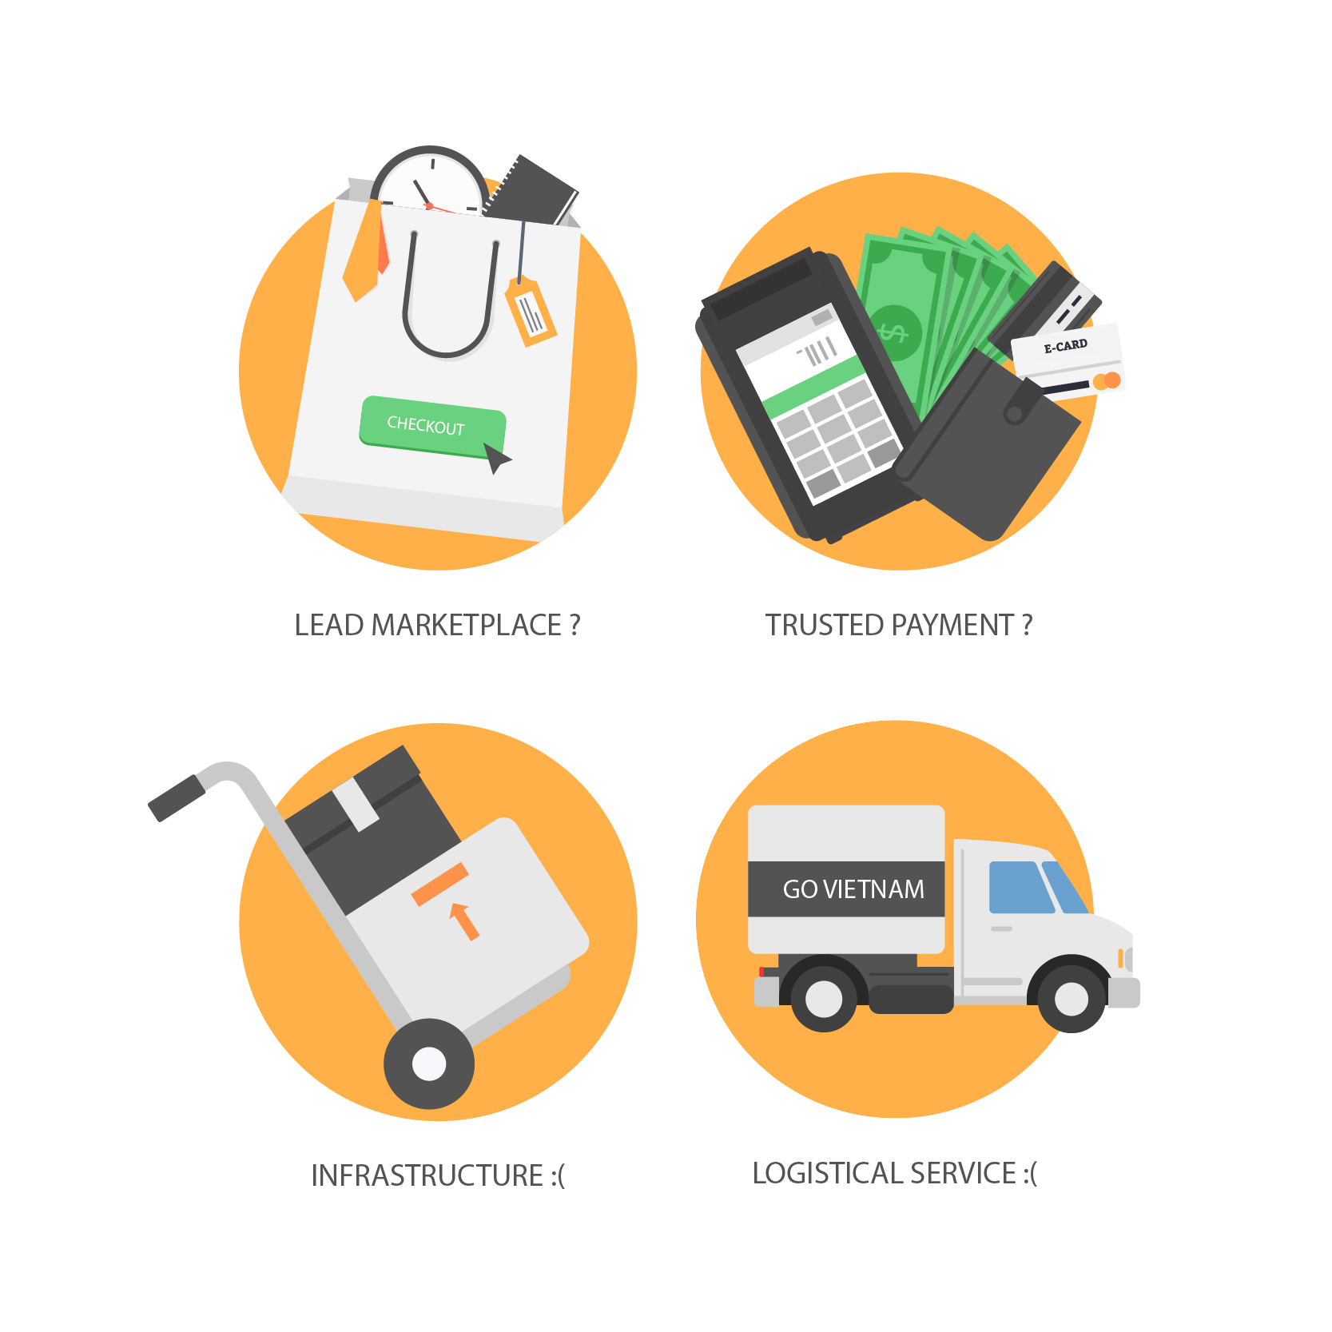

**The future of E-Commerce, set to “BOOM”**

To reach 90 million aspiring consumers with strongly growing incomes when the retail market is fragmented, quality retail space is rare and expensive companies need to understand the specific opportunities and challenges of the Vietnamese e-commerce market. A low credit card penetration rate and the limited popularity of bank transfers for instance mean that cash-on-delivery is still by the preferred delivery method. To adapt to this and other market conditions companies must tailor their offering and infrastructure accordingly.

Vietnamese consumers are looking for a simple payment method which can create the trust between the buyer and the seller, and a marketplace which is simple but convenient with great payment options, and not too many.

Vietnam has a lot of E-Commerce companies, however none of the players appears to have reached a market share of more than 5% because they could not solve the market problem. Newcomers who act quickly thus still have a fair chance to establish themselves as strong players in a relatively untapped market.

--------- end ----------

Author: Huy Le ([huyle@aseanecom.com](mailto:huyle@aseanecom.com)), Head of ASEAN-Ecom Group.

Data collected by ASEAN-Ecom Team from:

* *BMI Research*
* *PWC NewsBrief Vietnam Report*
* *EConsultancy*
* *Vietnam E-commerce and Information Technology Agency (VECITA)*

-------------------------

ASEAN-Ecom Group

**Who are we:**

ASEAN-Ecom is a group of globalized professionals forming a startup group to advance and develop the Southeast Asian E-Commerce infrastructure.

**What we do:**

We are creating an E-Commerce ecosystem by using technology to build online payment system, online trading platform (specific country & ASEAN Cross-border) and smart logistical service.

Contact: hello@aseanecom.com